**Final Report**

**Full Unit Project  
Benedict Wilkins**

**Supervisor: Zhiyuan Lou**

**2016**

**Table of Contents**

**Original Goals and Personal Standpoint** 4

**Original Abstract** 4

**Personal Development** 5

**Smart Meters, Energy Demand Management and Motivation** 5

**Energy Demand Management** 5

**Techniques for Supply Management** 5

**Demand Side Management and Smart Meters** 6

**Motivations** 7

**Introduction to Multi-agent Systems** 8

**Intelligent Agents** 8

**Multi-agent Systems** 9

**Distributed Agent Environment** 9

**Multi-agent Systems in Context** 10

**Agent Architecture** 11

**Perceive, Decide, Execute** 12

**Environment Architecture (Simulation)** 12

**House Environment** 12

**Environment and Physics** 12

**Global Environment and Physics** 13

**Software Engineering in the Java Based Multi-Agent System** 14

**Design patterns** 14

**State** 14

**Observer/Observable** 14

**Factory** 14

**Singleton** 15

**Check style** 15

**Test Strategies and TDD** 15

**UML** 15

**Revision Control** 17

**Data Generation** 18

**Introduction** 18

**Data Collection in Context** 18

**Data analysis** 18

**Low-Carbon-London-Dataset** 18

**First look at Seasonality** 19

**Building a Sampling Model** 20

**Combined Sampling Model** 22

**Seasonal Sampling Model** 23

**Initial look at Prediction Models** 23

**Introduction** 23

**Generated Data Analysis** 24

**ARMA** 25

**Machine Learning** 27

**Initial Exploration of Weka** 27

**Model Evaluation** 28

**Overfitting** 28

**Cross Validation** 28

**Cross Validation for Time Series Data** 29

**Time Series Models in Weka** 29

**MultilayerPerceptron** 29

**Developing the Model Further** 31

**Feedback loop** 31

**Thresholding** 31

**Modification** 32

**Implementation of Models, Modifiers and Thresholds** 32

**Missing Data** 34

**Simulation Scenarios** 35

**Scenario: Modification** 35

**Magnitude** 35

**Conclusions Regarding Modification and Underlying Model Functions** 35

**Scenario: Weka Multilayer Perceptron Forecasting** 36

**Null modifier** 36

**Magnitude Modifier** 36

**User Guide** 37

**Running** 37

**Extending** 37

**Professional Issues** 38

**Planning, Time Scale and Project Diary** 39

**Planning** 39

**Diary** 39

**Term One** 39

**Term Two** 40

**Evaluation and Review** 42

**Term One Review** 42

**Term Two Review** 42

**Project Review** 42

**Future Work** 42

**Bibliography** 43

**Appendices** 45

**Appendix 1. Project Plan MAS Structure** 45

# **Original**

## **Abstract**

Energy demand management (EDM) has become an increasingly pressing issue in our technological age. EDM, specifically demand-side management (DSM) is concerned with planning and implementing models that try to alter the habits of consumers. The end goal it to flatten energy demand peaks and reduce overall energy consumption [24]. Energy providers have a number of ways of managing fluctuations in energy consumption including but not limited to buying energy, energy storage techniques and employing peaking power plants.

This project aims to provide an alternative solution by integrating two closely related sub-fields of computer science; machine learning and multi-agent systems. This has become possible in context with the advent of Smart Meters, which are now being offered by providers such as British Gas. [25] Modelling these Smart Meters as agents and placing them in a distributed multi-layered environment allows automated data collection and pre-processing. Creating an automatic pipeline to feed agents with specialised prediction capabilities that will provide forecasts of the future consumption.

Artificial neural networks (ANNs) will provide these prediction capabilities. ANNs have proven to be an effective method of prediction and classification. They have been used in time series forecasting to model complex systems such as financial markets and foreign exchange markets and so will be suited to this problem [20]. ANNs have the ability to approximate highly non-linear functions and so have been used instead of more traditional statistical models. Using ANNs in this case will further explore their forecasting capabilities.

This report shows the processes involved with building such a system including background theory, motivation for the project, the design decisions, implementation details, discussion of future extension, problems faced, original goals alterations, and so on. A discussion of the motivations of the project will be given after a brief section on my career aspirations and personal goals in regards to the project.

## **Personal Development**

I hope that by the end of this project my understanding of Machine Learning in general when applied to an industrial problem will be deeper. If the original project goals are satisfied I believe I will be in a good position to move into a career focused in artificial intelligence, especially one that has some involvement in the energy industry (e.g. British Gas). Although I am already strong in java programming I also hope that my ability will improve as I am introduced to complex machine learning libraries. A side from java I will be using mathematical programming languages such as R in data analysis and exploration algorithms. All of this will further enhance my position when I eventually move from academia to industry. A review of my progress in these areas (essentially a self-evaluation) will be given towards the end of the report.

# **Smart Meters, Energy Demand Management and Motivation**

## **Energy Demand Management**

Energy Demand Management is in essence about managing the consumption/production of energy to ensure an effective energy network and to minimize cost and environmental damage. One of the main issues that EDM faces is how to efficiently supply energy to consumers. Peaks in energy demand arise when consumers – domestic or industrial, have synchronized habits. These lead to energy demand fluctuations (EDF), daily, weekly and seasonally [1]. These fluctuations must be dealt with by energy provides so not to result in damage to the energy network, blackouts and unpredictable service.

## **Techniques for Supply Management**

There are two general categories of power plant; base load and peaking. Base power plants are used to supply the base load power – the minimum requirement of energy over a period of time. They are usually nuclear, coal or large hydro-electric plants [2]. These plants are only turned off for maintenance or upgrades and usually provide power to a large area. Peaking power plants are one way to deal with EDF. They produce a variable amount of power which is matched to the current demand. Peaking power plants are expensive, heavily dependent on the fossil fuel market (as they are usually gas/coal burning plants) and are only usually used as a last resort after employing the methods mentioned below. See Figure 1.

Other techniques include energy storage and energy purchasing. Energy storage involves storing a large amount of energy and releasing it back to the grid during peak times. One of the most common examples of large-scale energy store are hydroelectric dams/pumps. Water may pumped during non-peak times or naturally build up behind a dam, later to be let through the turbines when it is required. A lot of energy is lost during this process and so it is not ideal. Energy purchasing is when an energy provider buys in energy from a separated grid. An example may be a British energy provider buying power from the French natation grid. Depending on the energy market this may be more desirable than using their own grid infrastructure.

## **Demand Side Management and Smart Meters**

Moving to the consumer side of EDM. Another way of approaching the problem (which will be the focus of this project) is to alter the habits of the consumers to reduce EDF. This will result in reduced cost for both energy providers and consumers. Demand response (DR) uses financial incentives to encourage consumers to alter their energy consumption habits. This method has been tested in the health sector; altering habits that relate to health by heavily taxing cigarettes and alcohol for example, has shown to be effective [3]. There have been various models that support DR in this projects context, see [4]. The National Grid (NG) in the UK has previously had meters to monitor electricity demand on a larger scale). Now however, with the advent of smart meters and their increasing popularity in the market, it is possible to collect house-hold specific data making it possible to implement DR.

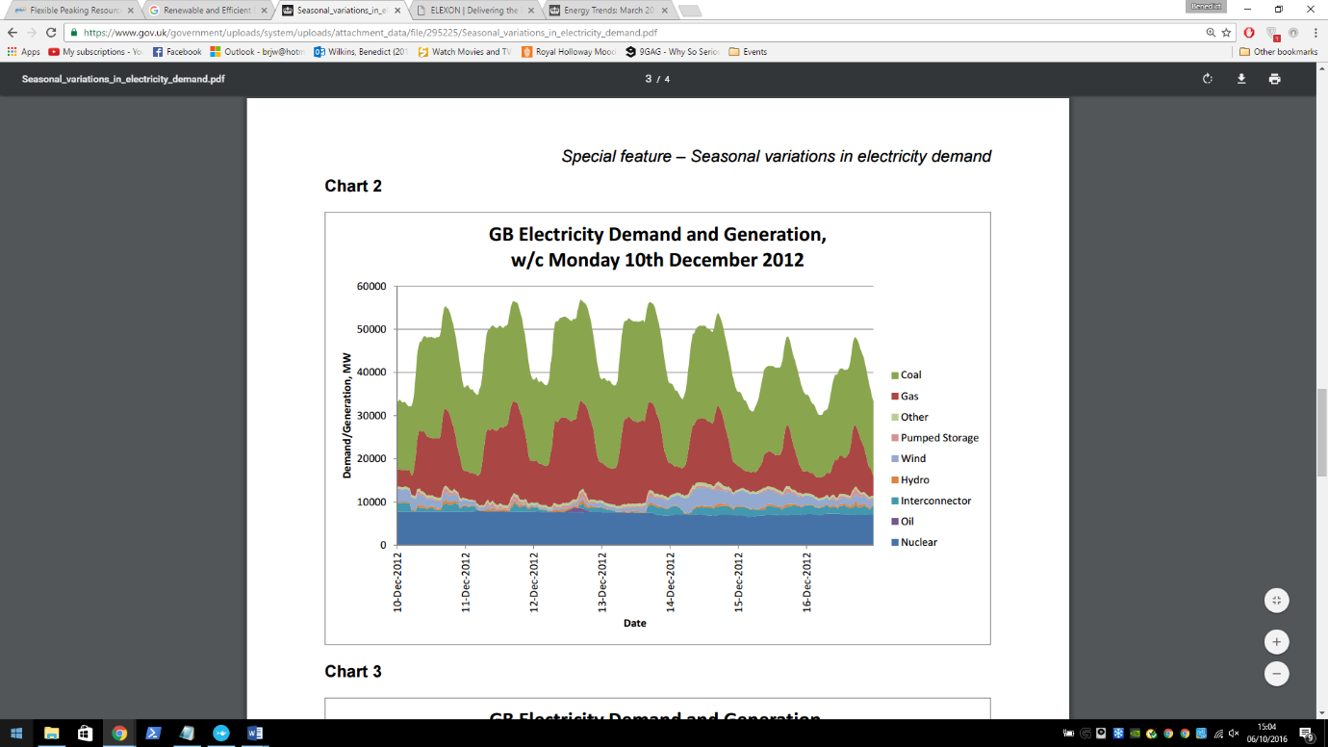

**Figure 1**. Taken from Special feature – Seasonal variations in electricity demand. See [1].  
The above shows the power demand/generation on the GB National Grid from 10 – 16 of December 2012 starting at midnight (00:00). It illustrates daily energy demand fluctuations and shows the use of peaking and base load power plants. Nuclear power plants are shown here to be the base load power plants. It is clear to see that gas and coal fire power plants are being used to deal with the EDF and so are the peaking power plants.

## **Motivations**

Machine learning is a heavily researched area in computing and is well suited in achieving this projects goal. Machine learning models require a few things to work but in essence; lots of data and a pattern. Both of those things seem to be present; data will be readily available from a large number of smart meters around the country and there is a pattern, looking a figure 1 gives a good indication that there is at least a daily pattern. ANNs should be able to model this pattern effectively and provide good predictions as a result. ANNs have been used previous to forecast for arguably more complex system including the stock market.

Using a multi-agent framework will provide a flexible but robust structure for the system, it allows the system to be easily distributed which is key if the system is to scale well. The real smart meters can be considered agents – they operate in some environment and their goal is to record energy related measurements from their environment. It will be useful to model the intermediate ‘processing’ layers as agents within layered environments. It will be easier to experiment with different pre-processing methods by switching agent behaviours, agents could also automatically report errors and/or statistics using different behaviours.

In conclusion, DR may provide a cheaper alternative to the supply management solutions presented above. There are some problems it cannot solve – for example large EDF when weather/seasons change, but it shows potential in helping reduce EDF on a day to day scale. Utilising Smart meters and current computing technology to create a more efficient energy grid will help reduce our impact on the environment and reduce cost for everyone involved.

# **Introduction to Multi-agent Systems**

## **Intelligent Agents**

There are a variety of definitions for what a software agent actually is. A good way to look at an agent is as a metaphor – the real world. We may consider a human as a real world agent. We exist in an environment - the universe, we have beliefs, desires and intentions which lead us to make decisions and ultimately perform actions which may or may not affect our environment. In essence this is what a software agent does but in a software context; it and its environment will be running on one or more machines. [6]

Continuing the metaphor, we as humans have a means to affect and observe our environment though use of our body. Parts of our body are used to perform actions in our environment – for example our hands can be used to pick up objects. In agent terms these parts are known as actuators or effectors. Other parts of our body are used for observation – for example our eyes, we look at the world and gather information about our environment. These parts are known as sensors. See figure 2 for an illustration of this idea. It is interesting to see how far this metaphor can be taken and how well it represents software agents – this will be discuss further in the *Agent Architecture* section.

The environment is key aspect of agent based systems. An environment is just some space in which the agents in the system are housed. Agent environments have a number of properties [7], in the later section *MAS in context* some attempt will be made to classify the environment of the system to be developed with these properties in mind.

In a lot of cases agents are in environment where other agents are also situated and so the need for communication between agents arises. These kind of systems are known as multi-agent systems.

Agent

Environment

Action

Perception

**Figure 2.** An illustration of an agent action on and observing an environment via is actuator and sensor.

## **Multi-agent Systems**

Agents interact with others agents in a variety of different ways depending on context. These interactions can be classified as a result from the following two agent behaviours; cooperative and competitive. Cooperative agents work together to achieve a common goal while competitive agents work to achieve their individual goals. It is not unusual for cooperative agents to display competitive behaviour and vice versa [8]. If an agent is *clever* enough it is easy to see how a competitive agent may behave like it is a cooperative. It may temporarily work with other agents if it finds that this is a more effective way of achieving its own goal.

Communication between agents is an important aspect of a multi-agent systems (MAS) and it provides the basis for agent interaction. Cooperative agents must have a means of communication in order to complete their goal as a group. They may need to dynamically organise themselves or communicate information that may be useful to the other agents. Competitive agents may also need to communicate. An agent based e-commerce trading system is a good example of a need for competitive communication. Each agent in the system will represent a real world entity such as a person or corporation. Their goal is to negotiate the best deal for the entity they are representing. They will require some communication protocol in order to negotiation [9]. It is up to the agent designer to provide these communication protocols in a way that best suits the system.

## **Distributed Agent Environment**

The nature of the smart grid forces the system to utilise some distributed agent environment. Smart meters are physically separate entities each with an environment that they are responsible for – the household of the consumer. The smart meter agents (SMA) will need to be capable of communicating information to physically separate systems. This can be done using an IP protocol. Each SMA will be capable of communicating in this way with its manager agent. There are a few different possible configurations of management agents all with different associated positives and negatives and are to be discussed in this section.

The hierarchical structure of the MAS implies groupings of the agents. The SMAs already have a natural grouping, by geographical location or address which is already used by all household service providers. The manager agent’s job should be to forward data on behalf of its group as well as manage and control them by forwarding commands from higher in the hierarchy.

To keep the system as de-centralised as possible it may be desirable to have the SMAs doing management themselves. They could delegate one of the other agents in their group to be a manager. This configuration may avoid system failures; if the delegated agent fails, a different SMA can be delegated as the manager. There is a potential privacy issue with sending data to a Smart Meter in a household, some measures would have to be in place to prevent data theft or alteration at the management agent location.

The alternative configuration is to have the management agent reside further up the hierarchy. It would be more complicated to deal with system failures as the system would have no alternative management agent. However there will be no privacy issues with sending the data.

## **Multi-agent Systems in Context**

There have been various other studies involving multi-agent systems and the smart grid [10] [11] [12]. W. *Multi-Agent Systems (MAS) controlled Smart Grid - A Review* in particular gives a good summary of relevant studies. Most are concerned with managing operations and control of the smart grid and some address problems such as the centralisation of power plants and service restoration.

This project is less concerned with the technology that will be used to implement the control/management of the smart grid after predictions have been made. However from the studies mentioned previously it seems likely that MAS will play a key role. This motivates the use of an extendable MAS in this project.

**Classifying the agent environment:**   
(From afore mention standard environmental attributes (Russel and Norvig 1995))

To begin classifying the environment we must first define what exactly we mean in context. Each SMA is situated in its own ‘house’ environment in which it interacts (take readings). The house environment is however linked to the global environment; the environment containing all houses and any other agents in the system. This is the environment which we will try to classify as it contains all other environments.

**Inaccessible** – due to the nature of networking. Each SMA does not know what is happening in some other part of the environment. It could ask for more information from the other agents but again there is no guarantee of a reply. Similarly the manager agents (whether they are central or not) do not have direct access to the house environments.

**Nondeterministic** – again due to the nature of networking. It is possible that the system will fail at some point, an SMA may fail and so no data will be sent up the hierarchy. It should be noted that the receiving agents should be able to handle not receiving any data. We do not want the employed machine learning method to fail because of this.

**Nonepisodic** – This attribute is a little harder to pin down. It could be said that the SMAs will reside in an episodic environment, all they will do it send data regardless of success or failure in the previous episode. In the simulated system the agents will receive an energy usage value every logical[1]* half hour interval. However it may be the case that in the real system the agent will be continuously monitoring the energy usage. Whether we consider the physical monitoring device part of the agent is up for debate and should be carefully considered in a fully deployable version of the system. The non-SMA (the agents higher up the hierarchy) are situated in a nonepisodic environment. Although data may be sent every half hour from the SMAs perspectives their time may be out of sync (this should be minimised as it will have an impact on prediction). The non-SMAs must be capable of continually receiving packets from the SMAs.

**Dynamic** – The environment will change independently of the each agent. Network failures and other agents may affect the environment.

**Discrete** – SMAs may only take an energy reading and send it. Non-SMAs may only receive messages, send messages.

## **Agent Architecture**

The arrows represent the forwarding of events, results and actions.

Body

* The mind generates an action based on some reasoning, this is forwarded to the brain, which forwards it to the body. The body then generates an event from the action which is forwarded to the actuator. The actuator then forwards the event to the environment.
* The sensor receives a result from the environment, this is the agent’s perception. The sensor forwards it to the body and in the same fashion as above it reaches the mind as a result. The mind can then process the result as it sees it.

**In Java:** Each part of the agent is represented as a class, each class is an observer observable pair (each class can communicate via observer/observable design pattern with its respective parts). The environmental also uses the observer/observable design pattern in order to send and receive results and events respectively. The body class contains all of the parts of the agent and so is essentially the complete agent. A body may also have an appearance which is defined as being; the external appearance of the body – what the agent looks like to other entities in the environment.

The framework for the agents is given by the GAWL (Generic Agent World Library) package. This framework also includes packages for, actions, events, perceptions, environment, physics and the observer/observable implementation. GAWL is essentially a revised version of the GOLEM framework see [13] and [14].[2]*

## **Perceive, Decide, Execute**

The architecture that is being used is an architecture used by the KGP model agency [15], where the agent control is based on a perceive-decide-act cycle, but implemented in Java rather than Prolog. In this project the agent control cycle will be explicitly referred to as the perceive-decide-execute cycle. The model is supported as a library within a revisited version of STARLITE [16] (STARLITE+), an agent platform that has been developed in the DICE lab at Royal Holloway ([http://dice.cs.rhul.ac.uk](http://dice.cs.rhul.ac.uk/)) to support the deployment of communicating software agents. Additionally see [17].

## **Environment Architecture (Simulation)**

### **House Environment**

**Data Generator**

**­­­­**

The SMA will receive a reading from the Data Reader agent – who in the simulation will be set to read a value from the Data Generator at a given time frame. The time frame will be decided at the beginning of the simulation, each frame will represent a half hour interval in the deployable system. The house environment/physics will be responsible for forwarding the Data Reader -> SMA message. Once the message is received the SMA will forward the data up the agent hierarchy. The Data generator module will be global and will depend on the set up of the simulation. It will provide data reading from all houses based on their properties e.g. what financial positon the house is in.

### **Environment and Physics**

Each house has its own physics and environment, these are responsible for message forwarding within a house and will evaluate events that pass through them making sure they are valid in context. For example a house environment will receive an event from the Data Reader agent, it will forward it to the house physics which will evaluate it in context, make sure it is possible and valid. It will then execute the action (in this case executing the action means giving it back to the environment enabling a forward to the SMA).

### **Global Environment and Physics**

The arrows represent the transfer of events. Each SMA in its respective House Environment will send a message to the Global Environment. This will be processed (sent to the physics) and given to the Group agent. The Group agent may be a neighbourhood, region, country or other defined at the start of the simulation. The Group agent will aggregate the data in some way and format it so that it may be useful to the Predictor agent. The aggregated data will be sent in the same manner from the Group agent to the Predictor agent.

There will be room in the architecture to provide multi group agents for different aggregations if needed. As an example we may have multiple neighbourhoods about which we want to make an aggregated prediction (a prediction regarding all houses in each neighbourhood). This can be done by simply having two Group (neighbourhood) agents with their respective House Environments. There is an obvious bottle neck at the Global environment/physics, this may be avoided by making a logical partition of the global environment e.g. for each group; a version of the global environment will be created to handle their communication specifically. In the real system the idea of Global environment will not hold as strong. The SMAs will forward their messages via IP communication – the machine who receives the message will essentially be the Global Environment.

**Global Environment**

**House Environment**

**House Environment**

**House Environment**

**Global Physics**

# **Software Engineering in the Java Based Multi-Agent System**

## **Design patterns**

### **State**

Allows an object to change its behaviour depending on its internal state by effectively changing its class.

The state design pattern has been used in many areas of my code. One example, the *SmartMeterAgentBody* class *brainHandler* attribute. The *brainHandler* attribute can be in one of two states – *NormalBrainHandler* or *IPBrainHandler*. This depends on the *Actuator* given to the agent at instantiation. One state allows the agent to handle *IPCommunicationActions* the other allows any non-IP related action e.g. *RecordAction*.

### **Observer/Observable**

The observer design pattern is used for event parsing between objects without explicit method calls. In java the *update* and *notifyObervers* methods are used to do this.

A custom version of the java implementation is used in GAWL for event parsing between agent parts, agents and environments, and environments and their associated physics. For of these concepts there is one or more classes in the system that represent them e.g. *NationalGridUniverse, SmartMeterAgentBody, HouseEnvironmentPhysics* etc.

### **Factory**

The factory design pattern provides an abstraction from object creation. No knowledge of the creation of the object is required, only the method in the factory for the desired object.

The *AgentFactory*, *EnvironmentFactory* and *HouseModelFactory* classes is are examples of the factory design pattern in the system. It abstracts from house model creation, only an error term is required for creation.

### **Singleton**

The singleton pattern is used to ensure that only one instance of a class can be created. This instance can be accessed in a static way, the class is responsible for the creation of this single instance.

The Factory classes above are examples of the singleton design pattern. Factories are always singletons as there should only ever be one instance at runtime.

## **Check style**

During the Java development process the google coding standards/check style was used to keep the formatting of code consistent and readable and also to make it easier to follow proper java coding standards.

## **Test Strategies and TDD**

TDD is a software development strategy in which the requirements of the system are broken up into essentially atomic tests. The tests are written and then code is written so that tests succeed. All tests are re-run each time the system is tested. The system is built up in this way so that (hopefully) by the end everything will work. In java JUnit is used for TDD, JUnit and a TDD strategy was used when testing some important utility classes such as *TestArgumentUltilities*, *TestTimeDateTracker*, and *TestMathUtilities* all of which can be found in the *test* package.

TDD was not a development strategy that would provide any advantage in the rest of the project. It becomes difficult to create unit tests for classes that interact heavily with one another and in a multi-threaded system it was nearly impossible. Instead, I used an integration based test strategy, testing the interacting between Observer/Observable pairs in a chain using simple print statements. For example to test event parsing between all parts of an agent – place a meaningful print statement in each *update* method and evaluate their order/correctness manually.

## **UML**

UML diagrams are used to explain and model a program graphically. They illustrate the design and architecture of the program and can also be used to identify architectural strengths/weaknesses. I created various UML diagrams for the project to illustrate the architecture of different areas. As the project is already quite large; I limited and divided them to only show the most useful areas.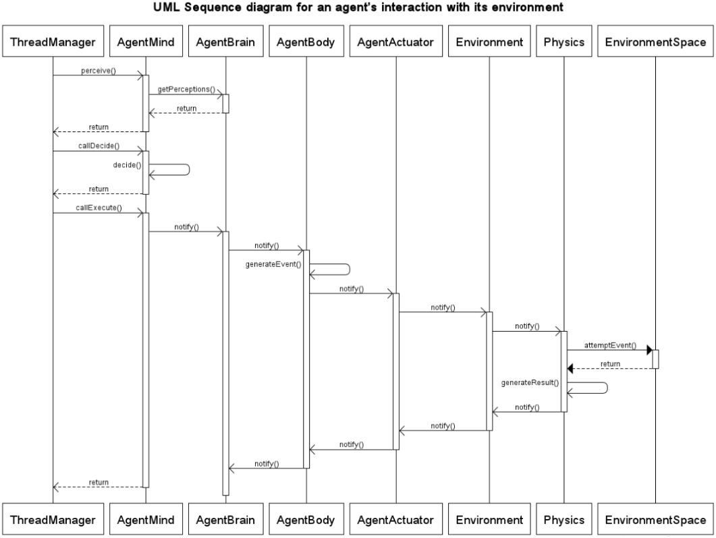

The above shows the interaction via observer/observer able notification of the different parts of an agent with the environment and the environment with its physics. All messages (except the *Physics* 🡪 *EnvironmentSpace* interaction) are asynchronous. The diagram is for a single agent only. In the real system there may be multiple agents interacting with a physics and environment (for example in the *NationalGridUniverse*).

**UML class diagram depicting the SmartMeterAgentMind and SmartMeterAgentBrain interaction/class structure** 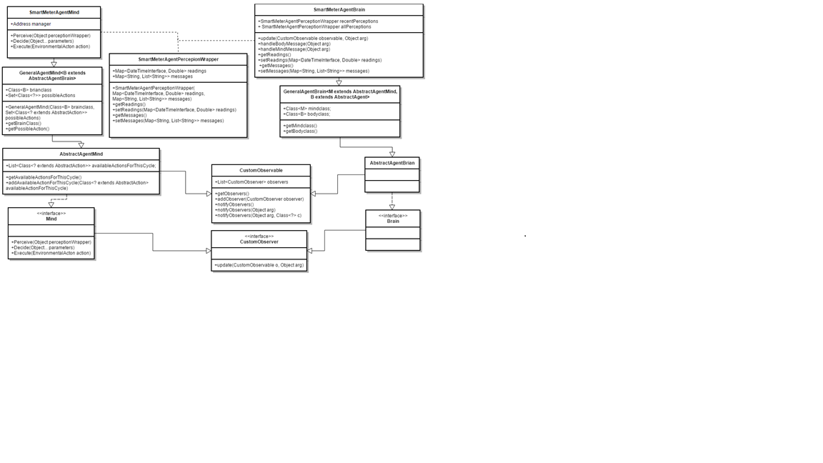

## **Revision Control**

Revision control systems such as Subversion and Git are used to store, manage, share code between developers working on a project. It will keep the entire history of the project (the versions) allowing more efficient code management and updating.

I have used Git as my revision control system (GitHub) out of personal preference. I have tried to regularly commit to this repository but my work on the project was quite modular so they tended to be fortnightly (see Planning below) and quite large. I have two branches: agentdemo and master. Agentdemo contains all the multi-agent system related code as well as the data generation code and testing. The master branch contains all reports as well as some R scripts for processing the London Low Carbon Dataset (see below) and for data analysis. The repository can be found at this address: <https://github.com/BenWilkins20/3rd-year-project.git>. Email – [ZAVC926@live.rhul.ac.uk](mailto:ZAVC926@live.rhul.ac.uk) to receive viewing permissions.

# **Data Generation**

## **Introduction**

Data will be generated by a Data Generation module which will be global – it will be accessible to all House Environments. When generating data we want it to represent a real scenario as much as possible. The best way to do this is to acquire some real data; the energy usage of different households, and fit a representative model to it. We can then sample from the fitted model to generate realistic data. It is necessary to perform some analysis of the data (see below section Data Analysis) to find a good representative model. The analysis of the data gives some insight into desired properties of a prediction model e.g. linearity.

### **Data Collection in Context**

It is important to look at the type of data that the system will be using. According to the Smart Metering Implementation Program [5], *‘GSME shall be capable of recording Consumption in each thirty minute period’.* (GSME - Gas Smart Metering Equipment), the same applies for Electric Smart Metering Equipment (ESME). There is also a daily recording option however this will not be suitable for the predictions that this project is concerned with. In principle the system will be able to support any reasonable time scale, but the most useful will be on an hourly time scale (because of the relatively large hourly EDF see figure 1.) The implementation details of the smart meter or what type of meter is irrelevant as long as the data is useable. With this in mind, the system isn’t necessarily limited to house-holds. Data may be collected from businesses/industrial settings. However it may be useful to make the distinction between the two as the scale/fluctuation pattern of each may be quite different.

The below section contains analysis of the Low-Carbon-London dataset. This data set exactly the kind of data that the simulation will be using – half hourly data in different households for different financial situations.

## **Data analysis**

### **Low-Carbon-London-Dataset**

The data set includes KWH per half hour readings for a number of households. The data set is grouped into Affluent, Comfortable, Adversity and ACORN-U depending on the customer status.

The first section from this containing 1 million entries was used in the analysis. The complete dataset contains 167 million entries. The sample below shows 8 rows of the data set with the column names.

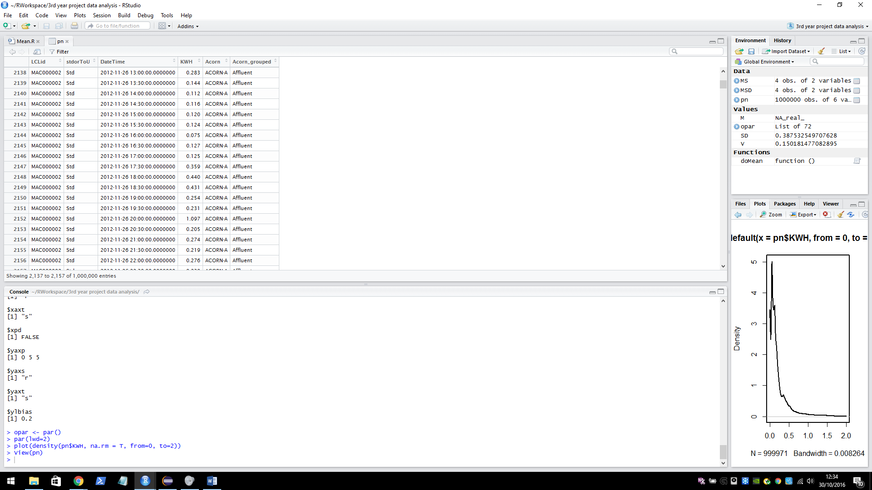**LCLid**: the unique house identifier.

**stdorToU**: Tariff.

**KWH**: energy used KWH per half hour.  
**Acorn/Acorn grouped**: the grouping of the customer.

The data set can be found here <https://data.london.gov.uk/dataset/smartmeter-energy-use-data-in-london-households>. Details on the ACORN groups can be found here <http://acorn.caci.co.uk/downloads/Acorn-User-guide.pdf>.

### **First look at Seasonality**

The plot below illustrates seasonality over the two years that data was collected. We can see that the average KWH usage is higher in the winter than in the summer. On the y axis: the mean KWH per half hour usage per day, on the x axis: the date (in days).

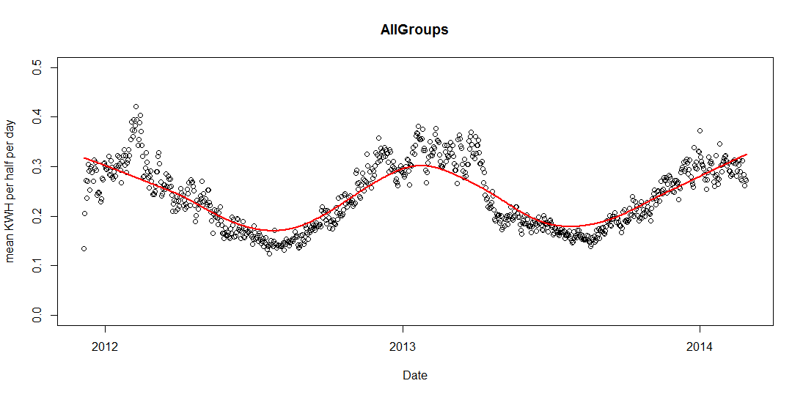The seasonality of each group varies, however for the sampling model one seasonality function will be developed that represents all groups. This will be similar to the above graph (the average of all groups). The graphs below show the seasonality of each group in the 2013 year.

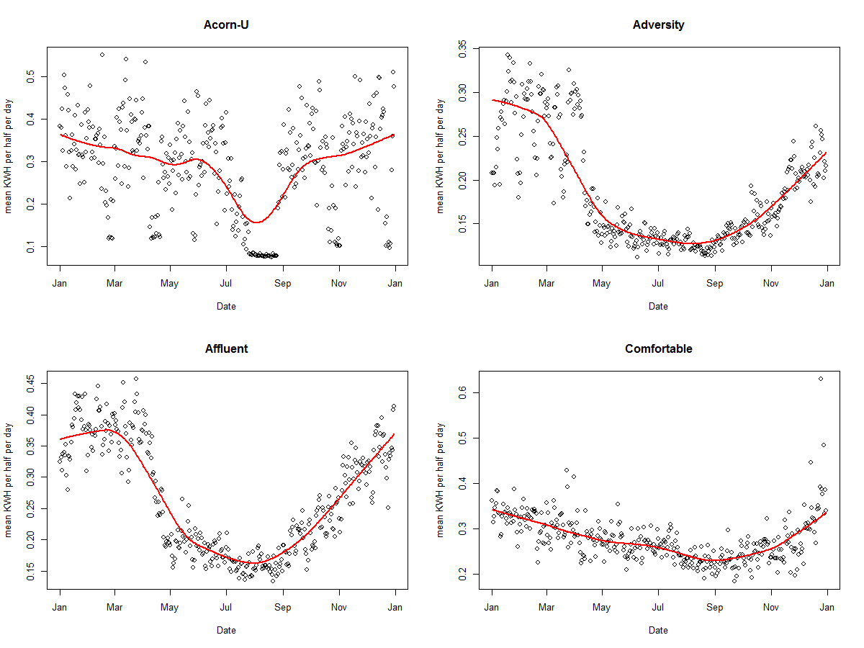

## **Building a Sampling Model**

When building the sampling model the equations for each group will take the form:

b­1*normal(μ1, σ1) + b­2*normal(μ2, σ2) + c

Manually fitting two normal curves to the mean KWH per half hour of the ACORN-U group. The blue line shows the fitted combined normal curve, the curve loops around the boundary, this is because hours are continuous – it is time series data. The red line shows a calculated mean values of the data group per half hour. The Y axis shows KWH per half hour, the X axis shows 48 half hourly time intervals which covers one day (24 hours) starting at 00:00:00 and ending at 11:30:00. (The graphs below were generated in the java class DataFitter using the JFreeChart graphing library).

|  |  |
| --- | --- |
|  | **Group: Acorn-U**  b­1 = 3.8  μ1 = 40.0  σ1 = 3.0  b­2 = 6.0  μ2 = 25.0  σ2 = 7.0  c = 0.1 |
|  | **Group: Adversity**  b­1 = 1.0  μ1 = 1.5  σ1 = 1.5  b­2 = 2.0  μ2 = 20.0  σ2 = 14.0  c = 0.12 |
|  | **Group: Affluent**  b­1 = 6.0  μ1 = 48.0  σ1 = 9.0  b­2 = 1.5  μ2 = 24.0  σ2 = 5.0  c = 0.15  discrepancy in normal curve * |
|  | **Group: Comfortable**  b­1 = 5.0  μ1 = 40.0  σ1 = 5.0  b­2 = 4.0  μ2 = 22.0  σ2 = 6.5  c = 0.1 |

**\*** In the Affluent graph there is a small discrepancy in the normal line. This is because the equation wraps around the boundaries up to half of the range in each direction. It occurs when there is a significant different in the middle values (for each wrapped half range), in most cases the difference is negligible because the normal curve tends to 0, it has negligible effect when added. In this case however the stand deviation of the curves is sufficient enough so that the line is not close to 0 and so the addition is noticeable. It will have a very small effect on the data sampling at the centre point but as the curve is an approximation and some error term will be added anyway it is not something to be too concerned about.

After a pure model has been built a random error term (*E*) will be added to each house representative of the noise in the real data. This term will be assigned at the beginning of a simulation.

## **Combined Sampling Model**

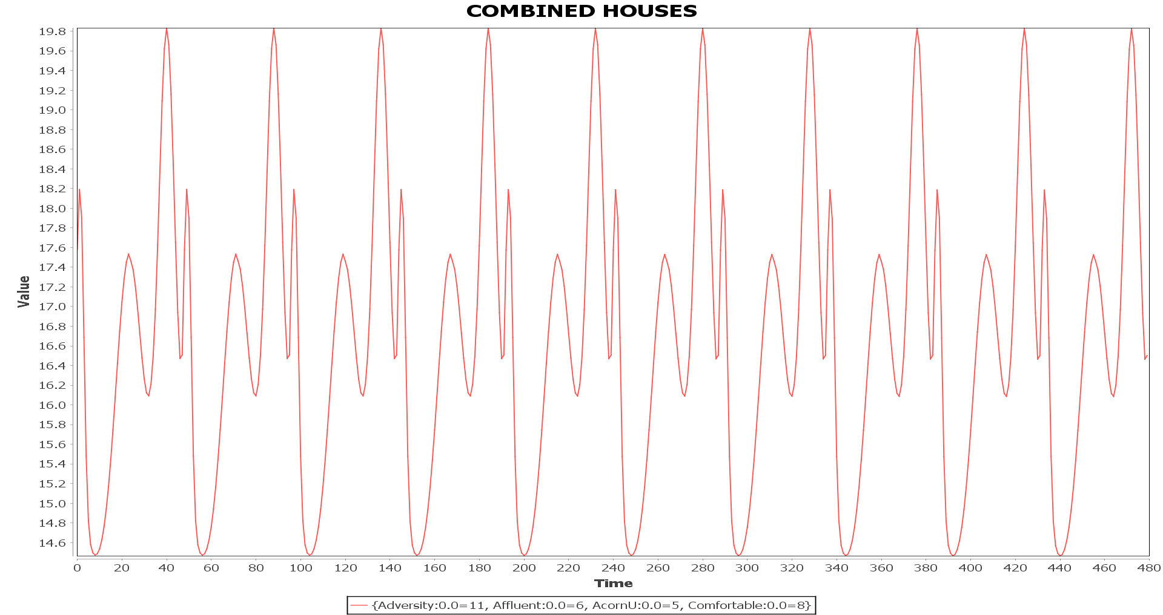The next step is to combine house models. The system has the capability to auto generate combinations of houses, this is representative of multiple SmartMeterAgents each employing their own consumption model. The below graph shows an example of a random combination of houses combined using an Additive combine (see the *Combinator* Interface and *AdditiveCombinator* class). In this case *E* given to each house model was 0 i.e. it is a pure model. The combination of houses used is as follows: 11 * Adversity, 6 * Affluent, 5 * AcornU, 8 * Comfortable for a total of 30 different houses (Information can be seen in graph legend, here value = energy consumption).

To demonstrate *E*, here is another example of a random house combination where *E* = 0.5.

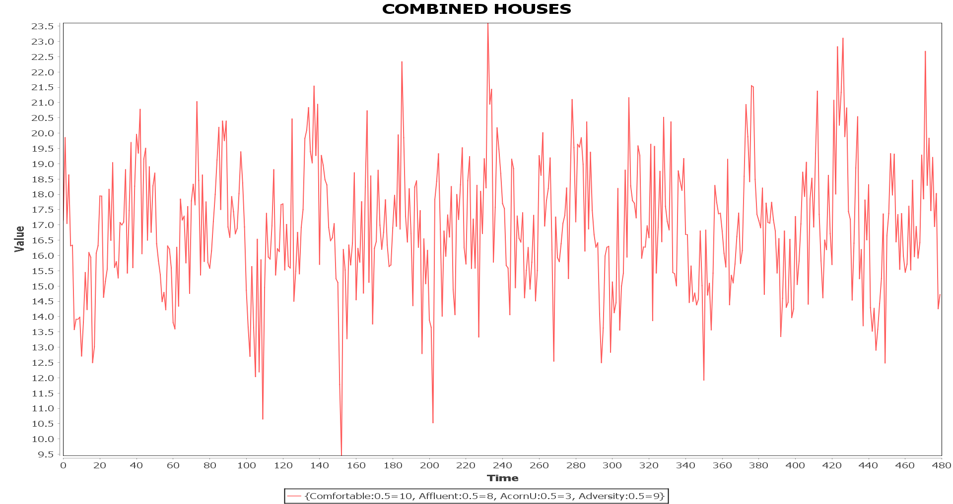

## **Seasonal Sampling Model**

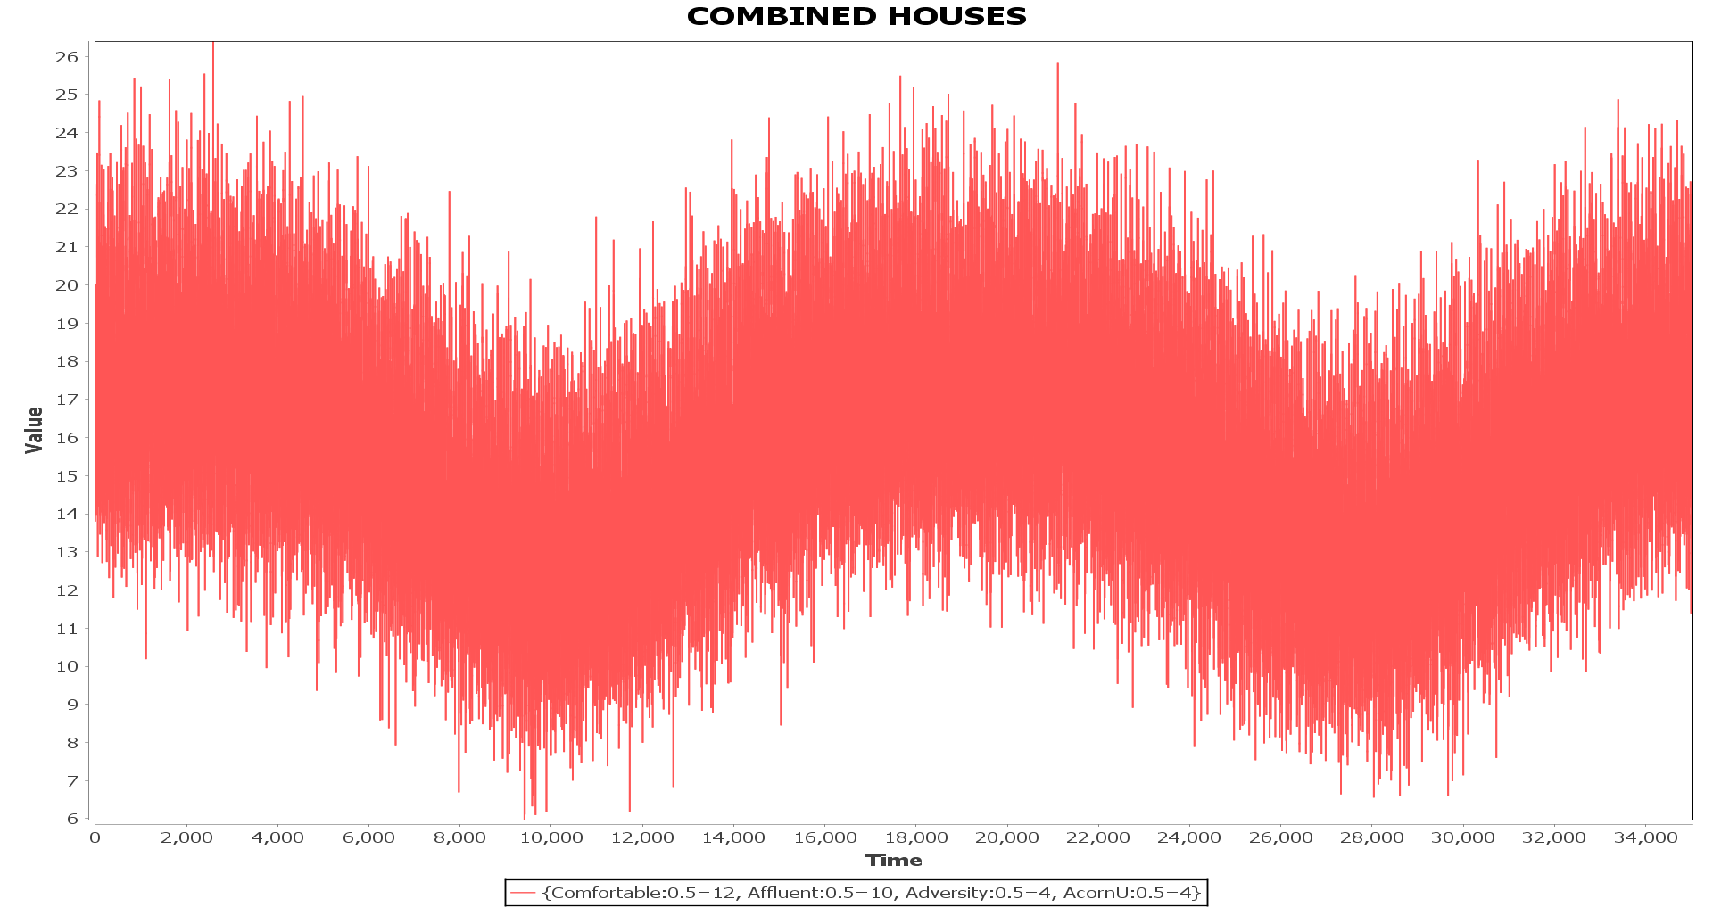Yearly seasonality is added to a model using the *SeasonalModifier* class. This model was built in a similar way to the house models (except using a single normal curve per year). Below shows data over a 2 year time frame, with *E* = 0.5 for some random set of houses. The series starts and ends during the winter season.

# **Initial look at Prediction Models**

## **Introduction**

ANNs have their advantages, but they also have their disadvantages. They are essentially a black box; the interpretability of their results is very bad. It will be advantageous in a business oriented environment to have at least some interpretability. There is an opportunity to test the use different machine learning techniques with the success of the data generation module. If a prediction model can be found that works as well or better than an ANN model then it should be seriously considered. Taking this opportunity, the next section will begin to test some alternative machine learning models.

It should be noted that this testing is completely separate from the multi-agent system as generating data through a simulation is unnecessary. A dedicated data generator will provide enough data to perform the tests (See *ExperimentDataGenerator* in the *demo* package). Different combinations of house models will be used to see if they will affect the prediction performance of the alternative methods. The testing will be done using R and using time series packages (R stats library).

## **Generated Data Analysis**

Below illustrates generate data for each group over a 10 day period.

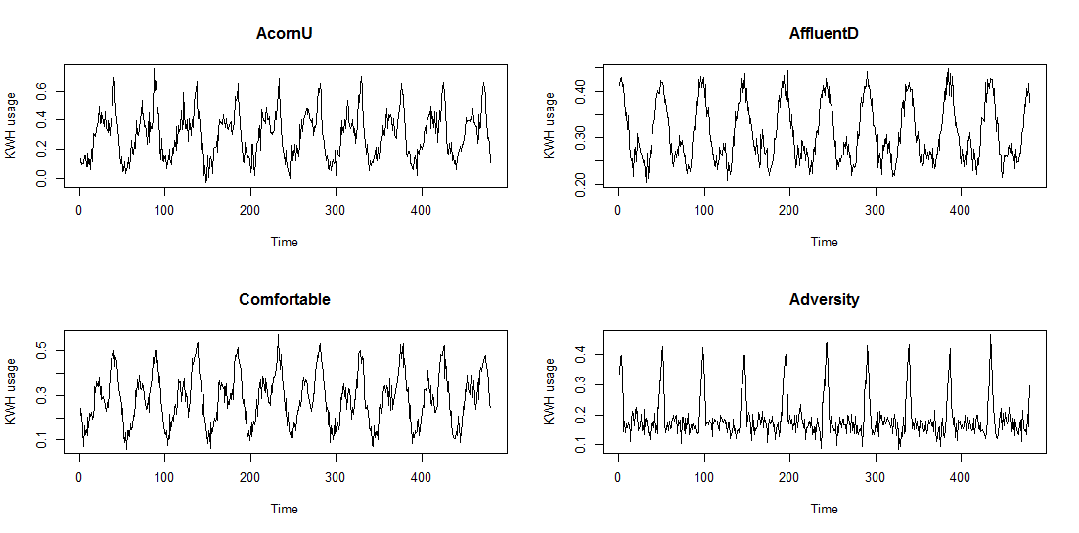

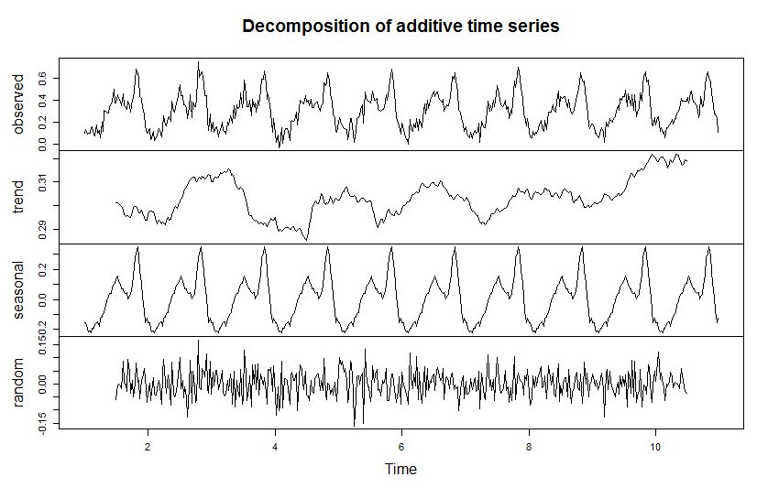**Decomposition of Acorn-U Generated Data**

The above is a sample of generated data over 10 days. It is nice to see that the seasonal trend (daily) looks somewhat similar to the Figure 1 (first section). The next step it to forecast for future data. Note that the data can be described by an additive time series model (which is required for the R function that did the decomposition (uses the ‘TTR’ R library)). At this moment the generated data does not include any yearly seasonality. Because the series is stationary – the mean, variance and covariance (of the i­th and i­th + n) term do not change with time (this may change when yearly seasonality is added). We can apply a basic ARIMA (or AR/MA) model for forecasting without having to employ any methods to make the series stationary (differencing, de-trending etc). The study below will use the Acorn-U generated series as its example.

## **ARMA**

Checking the auto-correlation function (AFC) and partial auto-correlation function (PAFC)

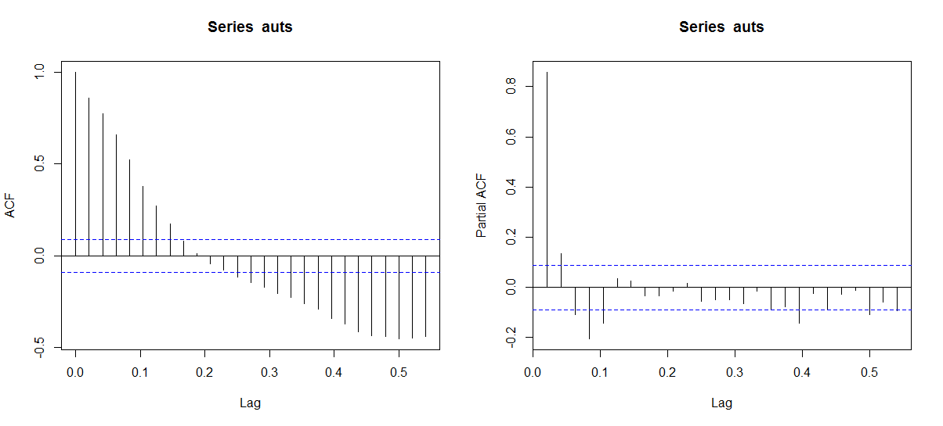

The PACF drops significantly after the 1st lag this implies that the series is an Auto Regressive (AR). Although the drop is significant, it does not level out until roughly lag 5. So the order can be between 1 and 5.

The AR model was tested with 3 different methods (R built in) – Burg, Yule-Walker (YW) and Maximum likelihood estimator (MLE). The models use 1 year of generated data (17520 half hour intervals). 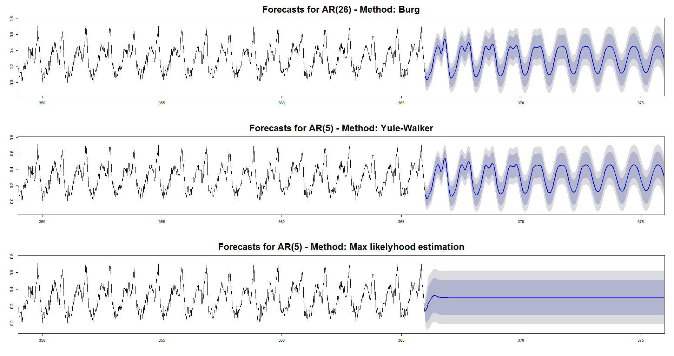

The Burg and YW methods perform quite well, they smooth out over time but the forecast is fairly accurate for the first few days. (The R code can be found in the *Analysis.R* file).

Although the forecasts given above are not bad, it is likely ARMA will not perform well when yearly seasonality is introduced into the data. For this reason the next section will focus on more advanced machine learning algorithms for forecasting and will introduce Weka as a tool for testing these algorithms.

# **Machine Learning**

**Weka**

Weka is a java based data mining tool, it includes tools for data pre-processing, classification, regression and visualisation among others. The Weka library can be accessed directly from java code which allows easy design of custom algorithms and machine learning schemes. Weka is available under the GNU General Public License and so is suitable for use in this project at least while it remains private research. If this work was ever to become commercially viable, Weka would be replaced by a specially design machine learning library to do this is a partial goal of the project but for the moment the Weka library in particular the algorithms provided by the TimeSeriesForecasting package will be used in testing.   
(Weka home page: <http://www.cs.waikato.ac.nz/ml/weka/>,   
TimeSeriesPackage:<http://wiki.pentaho.com/display/DATAMINING/Time+Series+Analysis+and+Forecasting+with+Weka>,<http://weka.sourceforge.net/packageMetaData/timeseriesForecasting/index.html> ).

## **Initial Exploration of Weka**

After building a façade between the Weka library and the current project build: (See: *MachineLearningMain* and *LearningExperimenter* classes (demo package)). These classes take the auto generated data from the *ExperimentDataGenerator* class and applies a given Weka Classifier (algorithm) to the data.

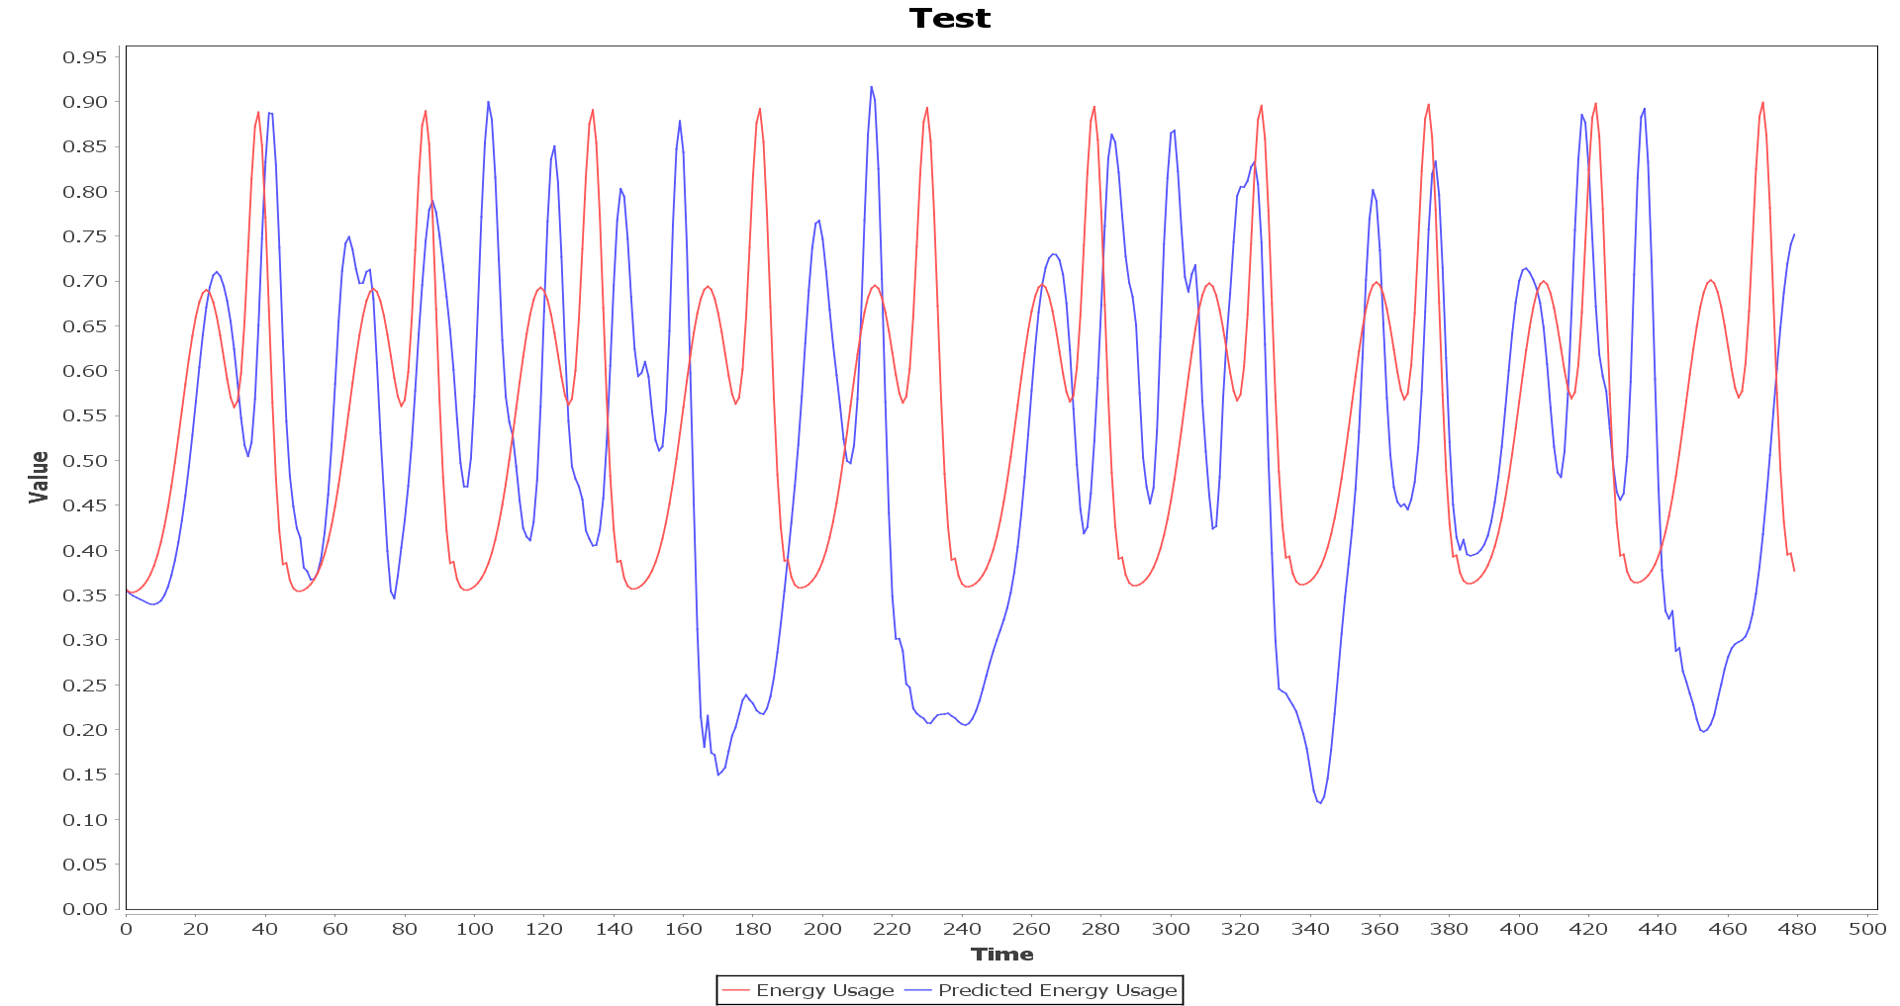The below graph shows the forecast given by Weka’s MultilayerPerceptron classifier with its default parameters. The given data is the pure Acorn-U model (0 error). The model was trained over 300 days (14400 instances) and attempts to forecast 10 days (480 instances).

## **Model Evaluation**

To perform evaluation of different models provided by Weka I will be using various error metrics the main being MSE: where is the prediction of the real value. To begin talking about the methods I will be using for evaluation some terminology and concepts must be introduced, these are as follows.

### **Overfitting**

When applying a model to some data, we are trying to represent a function that describes the process that generated the data. Data often comes impure – an element of random noise is involved, this we do not want to capture as it does not correspond to the process that generated the data but likely from the instruments or imperfect environments that the data was collected by/from. When a model captures this noise, we are overfitting the model. This usually happens if the model is excessively complex in comparison to the function we are trying to model. We do not require a 17th order polynomial model if the underlying model is linear. If a model is over-fitted it will likely perform poorly on data that has not yet been seen but very well on the current training data which is not what we want!

Underfitting is also an issue that must be considered, it is simply the opposite of overfitting – the model we are using is not powerful/complex enough to represent the function we are after, we want to avoid this as well. There are a number of techniques to avoid overfitting and underfitting, one of these which will be used in this project is Cross Validation.

### **Cross Validation**

Cross validation is a model evaluation method, in essence it tests a model against new data during the training process to hopefully reduce the chance of overfitting. K-fold cross validation involves splitting our data into K folds. In each fold we split the data in to test and training data (how this is done varies) and apply our model. For example K = 3:

Test

Training

Fold 1:

Test

Training

Fold 2:

Training

Test

Training

Fold 3:

All Data

A good value for k may be 10, we then split the data randomly into 90% training and 10% test data. Cross validation may be used for general machine learning models however it must be altered slightly for time series data as we cannot take random subsets of our data to form the test and training sets.

### **Cross Validation for Time Series Data**

In cross validation for time series data we still split into K folds. The folds look slightly different however. Say k = 3 again.

Test

Training

Fold 1:

Test

Training

Fold 2:

Test

Training

Fold 1:

This is the method that will be employed when evaluating the Weka models.

## **Time Series Models in Weka**

There are a few available time series models in Weka, each will be discussed in the following section. The Time Series Weka package performs the configuration of these models to suit them to time series data. This will also be discussed, as well as the control over parameters (such as lag) that the package provides.

They are as follows:

* MultilayerPerceptron (Artificial Neural Network)
* SMOreg (Support Vector Machine Regression Model)
* Gaussian Process
* Linear Regression

## **MultilayerPerceptron**

The MultilayerPerceptron classifier provided by Weka is an implementation of an Artificial Neural Network (ANN). To begin discussing this model some time will be taken to introduce ANNs in general and specifically for time series forecasting.

A basic Neural Network can be visualised as follows:

Networks are made up of layers of nodes (represented as circles here): Input is where data is fed into the network. Hidden are the nodes between Input and Output (they are called hidden because it is difficult to explicitly define their contribution to learning once training has begun). Output are the nodes which output data. The structure of the network depends on the problem to be solved and may have more than one hidden layer (known as a Deep ANN) and/or different size input/output layers.

Input

Hidden

Output

The model in question uses the famous Backpropagation algorithm to train the network and the activation function for neurons is sigmoid. [18]

# **Developing the Model Further**

One of the main goals of this project was to simulate Demand Side Management (DSM). We want the system to be able to adapt to changes in the customers behaviour – most importantly we want the forecasts to be representative of constantly changing consumer behaviour. We will be assuming that DSM is working i.e. the incentive for the consumer is high enough for them to alter their behaviour accordingly. To simulate this a feedback loop will be introduced into the system.

## **Feedback loop**

A brief note on combination, it was discussed previously in a sampling model context but here is a good opportunity to talk more about it in an agent context. The below diagram illustrates a simple example of combination between agents.  
Data that is received by the group agent is combined using its *Combinator*. The same process will occur if there happens to be multiple intermediate layers, i.e. group agents that reside above other group agents may combine their received data. Predictor agents are also capable of combination.

Predictor Agent

Group Agent

Smart Meter Agents

Now to the more complex discussion of feedback loop, we must first introduce two new terms – Threshold and Modifier the will be discussed respectively.

### **Thresholding**

A threshold in this context is about decision making in the case of a high level agent. An agent that uses a threshold is to make a decision about (something) based on a threshold query. It is best to illustrate this with a simple and relevant example.

We have an implementation of a threshold as the class: *MaximumThreshold*. We should start by defining its query in simple English, it is as follows: Given some numeric data, we compute the maximum value, if it is less than our threshold value then the answer to our query is no, if it is greater than or equal to our threshold value then our answer is yes. After a query has been made, it is up to the agent to decide what to do next based on the answer. In this example our agent may notice (this is where context becomes apparent) when our answer is yes, that the consumers are consuming too much, if the agents goal is to try to minimise consumption it may decide that it wants the behaviour of the lower agents to change - to consume less. How does an agent go about doing this? It uses modifiers, which are to be discussed next.

### **Modification**

Again it would be best illustrate the concept with an example. Say we have a class *ModelModifierMean*, and a function *ModelNormal* which represents a standard Gaussian distribution from which samples will be taken. The sole job of the *ModelModifierMean* class will be to alter the mean value of the *ModelNormal* function and so to ‘shift’ the function to the right or left. There are no restrictions on modification of a function other than the ones that are inherent in the implementation (to be discussed shortly). In principle, or at least in this system, a *ModelModifiers* job is to alter the ‘behaviour’ (by which I mean simply the function) of a model used in a system. I use behaviour instead of function contextually as it better describes the happenings in a real house hold, although in the simulation they can be used interchangeably.

### **Implementation of Models, Modifiers and Thresholds**

It will be helpful to discuss the implementation of these concepts in java as this (as in most cases of implementation) reduces perhaps first unseen restrictions. At the base lies the interface *MathematicalFunction* whose only method is: *compute* which takes in an *Array* of arguments of generic type (extending *Number)*and returns an *Array* of the same type. It is up to a class implementing this interface as to what compute does, but this method is essentially the function. (It should be noted that function is being used here as a computational term concerning numerical inputs and outputs, and is not related to the algebraic definition).

Given a *MathematicalFunction*, we would like to be able to modify it when it suits us. This is done by a class implementing *ModelModifier* whose only function is *Modify* which takes a single argument of type *MathematicalFunction* and returns the modified *MathematicalFunction* (of course in java the changes to the argument will be reflected in the callers reference to the object, giving a return value allows the function to be completely changed, even perhaps to return a different function altogether). In general, the relationship between *MathematicalFunction* and *ModelModifier* should be one to many. That is for each concrete implementation of *MathematicalFunction*, if we wish it to be modified we require a concrete implementation of *ModelModifier* for each example of modification we desire.

We should now move to discuss *Models*, this will be done in context to provide a more concrete example. Any modification of a *MathematicalFunction* in this system will be done through an intermediary - (as the name *ModelModifier* suggests) a *Model* and in this case, a *HouseModel*. The key interface for this process is *Modifiable*, this interface has a single method modifyModel which has a single parameter of type *ModelModifier*, a concrete implementation of this method should call the *modify* method and provide its underlying *MathematicalFunction* to it. In this system a *HouseModel* (which is the interface underlying all models that represent the behaviour of a household) extends both, *MathematicalFunction* and *Modifiable* and when calling *modifyModel* it will provide its underlying mathematical function (which is stored as an object).

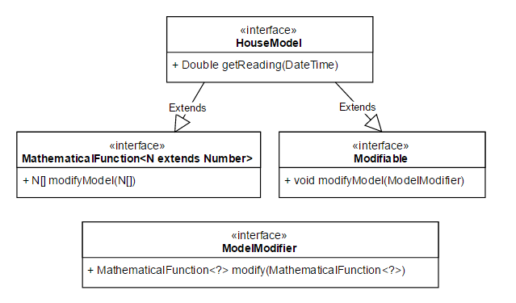

UML Class diagram showing the relation between the above mention interfaces.

The implementation of *Thresholds* is last to be discussed, it is given as an Interface with a single method *checkThreshold* which returns a True or False (Boolean) value has a single parameter of type *DataFrame* (a class that contains some data be it numerical or otherwise). A concrete class implementing *Threshold* should provide an analysis of the data in the given *DataFrame* and reduce it to a Boolean answer, the interpretation of this answer is up to the caller (i.e. the agent). Below shows the relation between each concept in the form of a UML sequence diagram, it also illustrates part what is meant by the ‘feedback loop’ in the system (the part being the altering of behaviour).

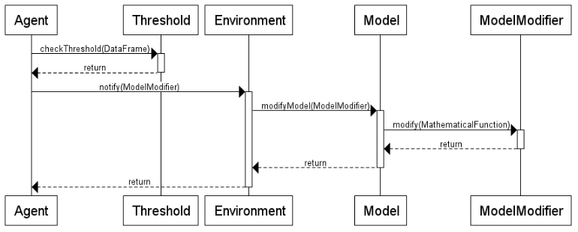

A number of intermediate steps are omitted (for simplicities sake) namely – the steps involved with the notify method between Agent and Environment. Here Agent means top level agent, e.g. the Predictor agent or Neighbourhood agent. Now we are in a good position to really define what we mean by feedback loop. After the top level agent depicted here has altered the behaviour of some underlying model(s) this is reflected in the data that is being collected by the lower level (*SmartMeter*) agents, this data is then streamed up the agent hierarchy as presented in earlier sections. This is essentially the definition of the feedback loop (given diagrammatically blow).

It should be noted here that a *Model* is not obligated to change its behaviour and in the context of this project it seems right that a *Model* most, if not all of the time should not change its behaviour, at present probability is used as the deciding factor (i.e. each model may have a 5% chance to change when presented with a *ModelModifier* by the top level agent).

Models

Modify

Provide

Diagrammatic feedback loop. The bottom edge represents data collection performed by the SmartMeterAgents.

The purpose of the feedback loop is to provide accurate simulation of a dynamic environment. If the motivation for this project becomes reality (i.e. if Demand Side Management works and the behaviour of customers is actually changed), then an algorithm that is used in forecasting must be able to adapt and learn these new behaviours in order to perform well. Given this development in the system it will be possible to simulate such an environment and test such algorithms. To further illustrate the capabilities of this development some scenarios will be run and results given in the next section.

## **Missing Data**

Here we will address the problem of missing data. In a real world setting in which network failures are possible, it may be that some SmartMeterAgents fail to report readings for given times either completely i.e. they are lost, or partially i.e. they are sent later in time than what is expected. In both cases the top level agents must be able to deal with such an event. Presently a simple mechanism is in place to deal with this – when combining data from each SmartMeterAgent, if any data is missing for a given time, the average of the other examples for that time is used to fill the empty slot. This is by no means a comprehensive solution, and is hardcoded into the *ReadingCombinator* class (which handles the combination of readings from SmartMeterAgents given a base *Combinator* such as an *AdditiveCombinator*). As a future extension to the project, this should be implemented in a more flexible fashion – to give the option to provide different ways of handling missing data. One such example may be to take the previous reading from the same house.

It should also be noted here that somewhere in the simulation there is a failure; occasionally a SmartMeterAgent does not report its reading during simulation, this is an expectedly difficult bug to find but the prime suspect is the thread management system. Due to time constraints it will not be full addressed. As luck would have it, it provides a good demonstration for missing data so also for the techniques used to solve the missing data problem so it is not a top priority, although it does illustrate a flaw in the system architecture.

# **Simulation Scenarios**

A series of scenarios are to be presented in this section, some standards will be set now for the sake of simplicity of demonstration. The error *E* will be set to 0.0 and remain constant between each house and between scenarios. Each scenario will use four houses, and a single neighbourhood and predictor agent unless its purpose is to demonstrate otherwise.

## **Scenario: Modification**

### **Magnitude**

The magnitude modifier scales the function by some value, in this case the function is scaled by 0.99 (i.e. all values in the function will be reduced by 1% each time the function is modified). In another example it may be possible for the function to grow however in this context an agents goal should always be to reduce energy overall consumption.

### **Conclusions Regarding Modification and Underlying Model Functions**

It has come to light that the combined normal function and its implementation was not the most practical and extendable model to use. This became apparent after an attempt at creating a ShiftModifier (a modifier that would shift the function left or right by some amount), as the implementation used a ‘loop around the edge’ approach it was difficult to specify the correct modification in the modifier. Given that the system is set up to use any function as a base for house models solving this issue can be thought of as a possible extension to the project. To change the function from being two normal distributions to being sinusoidal would be one valid option. In hindsight it would have been better to implement the model function as sinusoidal in the first place.

## **Scenario: Weka Multilayer Perceptron Forecasting**

### **Null modifier**

Given a null modifier, the Weka implementation of ANN performs quite well, a forecast of the next 10 days was given after training on the first 50 days.

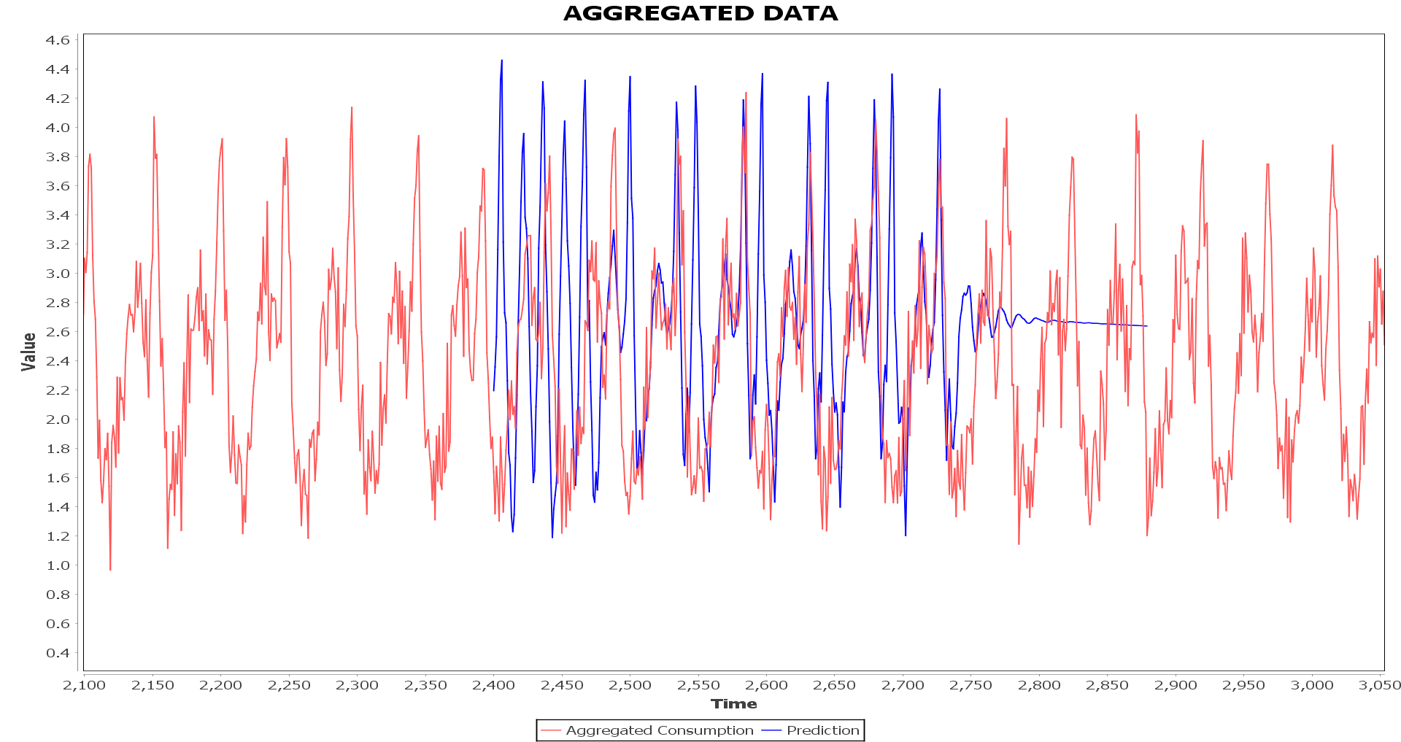

### **Magnitude Modifier**

# **User Guide**

## **Running**

## **Extending**

# **Professional Issues**

# **Planning, Time Scale and Project Diary**

## **Planning**

I have not followed the original project plan, especially the sections related to ANNs. I was too ambitious with the time frames that I designated for each report/program, it would have been wiser to move the machine learning related tasks to the second term. Now knowing that an ANN based model may not be the way to go, it is fortunate that I had not already implemented the relevant proof of concept programs/written relevant reports. Most of the machine learning related work will be done next term. I have however had the opportunity to do some fairly extensive background reading on ANNs for time series prediction and machine learning in general [18] [19] [20] [21] [22] [23] which will give me a very good base for next term. I have progressed quite far with the simulation system. Data generation is complete, the multi-agent system is almost complete all that needs to be done is to create some integrated machine learning capability in an agent mind.

## **Diary**

I had meetings with my supervisor – Dr Zhiyuan Lou and occasionally Prof Kostas Stathis every fortnight on Wednesday. The meetings were very useful in evaluating the progress of the project. Because of these fortnightly meetings I tended to work in chunks every two weeks – which is why my revision control (git repository) sees fortnightly commits. The meetings are as noted below:

### **Term One**

**12th October:** General discussion about the project and how to proceed. Discussed the multi-agent architecture to be used and what reports I will be writing this term.

**26th October:** Kostas was involved with discussions on the project. Talking about the different layers of the architecture – including where in the agent system the predictors should reside. Talked about having area/neighbourhood agents having prediction capabilities for the houses they are responsible for. Discussed moving away from the ANN model in favour of a simpler model. This may be the way to go as ANN can be difficult to use/explain. I have put the multi-agent report on hold to work on the data generation section of the project. We agreed that this section was more appropriate as a means to continue the project effectively as the data will be relied upon when starting the prediction section. A good portion of the Multi-agent system has been completed by this point, agent communication via sockets, house environments with (after data generation section has been completed – will be implemented) the capability of holding and retrieving data from a generic data generator. The presentation at the end of term should have a demonstration graphic of the prediction working – e.g. a graph with 2 lines, one for real data and one for the prediction. The lines will extend across the graph with time.

**9th November:** Kostas was involved in the meeting again. I briefly demonstrated the multi-agent system to Zhiyuan and Kostas as well as the data generation program and report. We discussed the architecture of the House Environment, Kostas suggested that a data reading agent should be used to get readings from the generator and forward them to the Smart Meter Agent. This method seems better than the current one – where the smart meter agent reads at a clock tick on a global timer. We again spoke about the ANN implementation and after looking at the data analysis section of the Data Generation report decided that testing different prediction models would be a good addition to the project. Having this meeting allowed me to finish the Introduction to Multi-Agent Systems report, specifically the sections about the architecture used in the project.

**23rd November:** Final meeting this term. With Zhiyuan only, we spoke about the presentation, interim viva and how to proceed with the project. He advocated that I had at least some machine learning work to present for the interim report. I will now work on some basic forecasting on generated data. The forecasting will be done using prebuilt time series machine learning packages (probably in R). At least some experimentation will be complete by the time the report is due, the rest will be done over the Christmas break. I will be implementing the most successful machine learning methods next term.

### **Term Two**

**17th January 2017:** Meeting with Zhiyuan, We discussed the progression of the project, work over the Christmas break, and where to go next – what are the plans for this term. We agreed this this term should focus on integrating machine learning into the project. The agent section of the project is almost complete, it only requires integration of machine learning and agent minds (for the learning agents). We decided that Weka was the library of choice, over the next weeks I will spend time getting to grips with Weka and slowly integrate it into the project.

**31st January 2017:** Second meeting of the term with Zhiyuan. We discussed progress with Weka, I showed an example of the MultilayerPerceptron forecasting model training and forecasting on some auto generated data – it did not do very well. We concluded that more work was needed to tweak and test different algorithms. I am now working on an automated algorithm tester (some meta-learning!) to try and find the best algorithm and parameters for the job. I had previously been using the built in Weka forecasting algorithms on their default settings.

**15th February 2017:** Midweek meeting with Zhiyuan and Kostas, I presented my work so far to them, which included drawing an outline of the structure of the project and showing my progress up to this point. We discussed where the project should go from there – that the feedback look should be implemented, this involves some kind of thresholding mechanism that a top level agent may use in order to request a change in behaviour of the underlying consumption models. The models should be able to be modified in a number of ways: shifting, magnitude etc. Once this has been implemented the next step will be to build a (basic) visualisation of the system and to test prediction models supplied to the PredictorAgent. I have no made much progress on the report at this point but it is important to finish the code as then I will have a complete project (and it will be easier to write about).

**1st March 2017:** Meeting with Zhiyuan. I demonstrated that the work to be done that was discussed in the last meeting had been completed, namely, the feedback loop, thresholds, and a way to alter the behaviour of consumers using ‘modifiers’. We discussed where to move next, Zhiyuan suggested that I present some interesting scenarios in my final report and that I should focus on writing about what the project has achieved so far. It should be noted here that of course the complete goals of the project have no be met – the machine learning/forecasting is lacking to say the least. It will however, likely be pursued in future work as it is a question of time not capability.

# **Evaluation and Review**

### **Term One Review**

### **Term Two Review**

### **Project Review**

### **Future Work**

# **Bibliography**

|  |  |
| --- | --- |
| [1] | C. Gaven, “Seasonal variations in electricity demand,” Department of Energy & Climate Change, 2014. |
| [2] | European Nuclear Society, “Base load power plants,” [Online]. Available: https://www.euronuclear.org/info/encyclopedia/baseloadpowerplants.htm. |
| [3] | S. R. E. M. F. F. S. J. A. Emma L. Giles, “The Effectiveness of Financial Incentives for Health Behaviour Change: Systemtic Review and Meta-Analysis,” 2014. |
| [4] | C. D. A. L. S. P. A. M. Antonios Chrysopoulos, “Agent-based small-scale energy consumer models for energy portfolio management,” *2013 IEEE/WIC/ACM International Joint Conferences on (Vol. 2, pp. 94-101). IEEE.,* 2013. |
| [5] | Department of Energy & Climate Change, “Smart Metering Implementation Programme, Smart Metering Equipment Technical Specifications,” Department of Energy and Climate Change, 2014. |
| [6] | M. Wooldridge, An introduction to multiagent systems, John Wiley & Sons, 2009. |
| [7] | S. Russell and P. Norvig, Artifical Intelligence. A modern apprach, Prentice Hall, 1995. |
| [8] | P. J. '. Hoen, K. Tuyls, L. Panait, S. Luke and J. A. La Poutré, “An Overview of Cooperative and Competitive Multiagent Learning,” *Lecture Notes Computer Science,* vol. 3898, pp. 1-46, 2006. |
| [9] | I. Rahwan, R. Kowalczyk and H. H. Pham, “Intelligent Agents for Automated One-to-Many e-Commerce Negotiation,” *Autralian Computer Science Communications,* vol. 24, no. 1, pp. 197-204, 2002. |
| [10] | C. Yilmaz, S. Albayrak and M. Lutzenberger, “Smart Grid Architectures and the Multi-Agent System Paradigm,” in *Proceedings of the 4th International Conference on Smart Grids, Green Communications and IT Energy-aware Technologies.*, Chamonix, 2014. |
| [11] | A. Rogers, S. D. Ramchurn and N. R. Jennings, “Delivering the Smart Grid: Challenges for Autonomous Agents and Multi-Agent Systems Research,” in *Twenty-Sixth AAAI Conference on Artificial Intelligence (AAAI-12)*, Toronto, 2012. |
| [12] | M. S. Narkhede, S. Chatterji and S. Ghosh, “Multi-Agent Systems (MAS) controlled Smart Grid - A Review,” in *Proceedings on International Conference on Recent Trends in Engineering and Technology*, 2013. |
| [13] | B. Alrayes, O. Kafali and K. Stathis, “RECON: A Robust Multi-agent Environment for Simulating COncurrent Negotiations,” *Advances in Agent-base Complex Automated Negotiation,* pp. 157-174, 2016. |
| [14] | S. Bromuri and K. Stathis, “Situating Cognitive Agents in GOLEM,” *Lecture Notes in Computer Science,* vol. 5049, pp. 115-134. |
| [15] | A. Kakas, P. Mancarella, F. Sadri, K. Stathis and F. Toni, “Computational Logic Foundations of KGP Agents,” *Journal of Artificial Intelligence Research 33 (2008) 285-348,* 2008. |
| [16] | J. Hopkins, O. Kafali and K. Stathis, “Open Game Tournaments in STARLITE.,” in *Proceedings of the 14th International Conference on Autonomous Agents and Multiagent Systems*, 2015. |
| [17] | K. Stathis and F. Toni, “The KGP model of agency for decision making in e-negotiation,” 2005. |
| [18] | H. Allende, C. Moraga and R. Salas, “Artifical neural networks in time series forcasting: A comparative analysis,” *Kybernetika,* vol. 38, pp. 685 - 707, 2002. |
| [19] | MachineLearner, “CS231n Lecture 10 - Recurrent Neural Networks, Image Captioning, LSTM,” 14 June 2016. [Online]. Available: https://www.youtube.com/watch?v=iX5V1WpxxkY. |
| [20] | B. Oancea and S. C. Ciucu, “Time series forecasting using neural networks,” *arXiv,* p. 1, 2014. |
| [21] | S. Miller, “Mind: How to Build a Neural Network (Part One),” 10 August 2015. [Online]. Available: http://stevenmiller888.github.io/mind-how-to-build-a-neural-network/. |
| [22] | T. M. Mitchell, Machine Learning, MIT Press, The McGraw-Hill Companies Inc, 1997. |
| [23] | PyData, “Alex Rubinsteyn: Python Libraries for Deep Learning with Sequences,” 4 December 2015. [Online]. Available: https://www.youtube.com/watch?v=E92jDCmJNek. |
| [24] | B. Davito, T. Humayun and U. Robert, “The smart grid and the promise of demand-side management,” McKinsey and Company, 2009. |
| [25] | British Gas, “Smart Meters,” 2016. [Online]. Available: https://www.britishgas.co.uk/smarter-living/control-energy/smart-meters.html. |
| [26] | Smart Energy GB, “About the rollout,” [Online]. Available: https://www.smartenergygb.org/en/the-bigger-picture/about-the-rollout. |
| [27] | nelsonminar, “Energy usage notes,” 31 Janurary 2012. [Online]. Available: https://nelsonslog.wordpress.com/2012/01/31/energy-usage-notes/. |
| [28] | “BBC News,” [Online]. Available: http://news.bbc.co.uk/1/shared/spl/hi/guides/456900/456991/html/. |

# **Appendices**

## **Appendix 1. Project Plan MAS Structure**

The agents will be placed in a multi-layered environment, each layer will contain one or more agents and each agent in a layer may be a manager of some agents in the layer below illustrated in figure 1. The system will be developed to have arbitrary layers in this fashion with the top layer agent(s) as prediction agents, the bottom layer as data collection agents and intermediate data pre-processing agents. Depending on the amount of data pre-processing to be done it may be preferable to distribute the system in terms of layers or agents. The agents will have the capability to communicate via an internet protocol of choice. This can be done using the Starlite framework as it allows sensor/actuator modules to be attached to the agents, these modules can be set up to accommodate any protocol. The full details of the Starlite framework will be discussed in the Introduction to Multi-agent Systems report mentioned below.

**Figure 1.** AL is an agent at layer L. A0 will typically be the prediction agent – in this case the one that uses the ANN. Agents directly below A0 will be supplying it with clean formatted data. The bottom layer of the hierarchy will be reserved for data collection – in this case the smart meter agents. The lines represent communication channels between the agents. These channels will be used to send the collected data up the hierarchy. The channels will be bi-directional as an agent may want to send control data to an agent it is managing. See figure 2 for an illustration of communication channels.

A0

A11

A211

A12

…

A1n-1

A1n

A212

…

…

…

…

…

A21m

A2n1

A2n2

A2nm’

…

A0

A11

Upper layer agent

Lower layer agent

Control Data

Collected Data

**Figure 2.** Control data is sent down the hierarchy and the collected data – in this case the smart meter data is sent up the hierarchy. Control data may be any data and will depend on the systems use. In this system it may be instructions for data pre-processing.

1. * The half hour interval will not be in real time, it will be scaled to simulation speed.
2. * Note: GAWL was developed by Prof. Kostas Stathis, Emanuele Uliana and myself and is based upon work that Prof. Stathis (and colleagues) have worked on previously including GOLEM and STARLITE.